BIOLOGY

UNIT 3

2021

Name:

Teacher:

Time allowed for this paper
Reading time before commencing work: ten minutes
Working time: three hours

Materials required/recommended for this paper
To be provided by the supervisor
This Question/Answer booklet
Multiple-choice answer sheet

To be provided by the candidate
Standard items: pens (blue/black preferred), pencils (including coloured), sharpener, correction fluid/tape, eraser, ruler, highlighters
Special items: non-programmable calculators approved for use in this examination

Important note to candidates
No other items may be taken into the examination room. It is your responsibility to ensure that
you do not have any unauthorised material. If you have any unauthorised material with you, hand
it to the supervisor before reading any further.

Structure of this paper

Section | Number of questions available | Number of questions to be answered | Suggested working time (minutes) | Marks available | Percentage of examination
Section One  Multiple-choice | 30 | 30 | 40 | 30 | 30
Section Two  Short answer | 5 | 5 | 90 | 100 | 50
Section Three  Extended answer  Part A | 2 | 1 | 50 | 40 | 20
Part B | 2 | 1
 |  |  |  | Total | 100

Instructions to candidates

1. The rules for the conduct of the Western Australian external examinations are detailed in the Year 12 Information Handbook 2021. Sitting this examination implies that you agree to abide by these rules.

2. Write your answers in this Question/Answer booklet preferably using a blue/black pen. Do not use erasable or gel pens.

3. Answer the questions according to the following instructions.

Section One: Answer all questions on the separate Multiple-choice answer sheet provided. For each question, shade the box to indicate your answer. Use only a blue or black pen to shade the boxes. Do not use erasable or gel pens. If you make a mistake, place a cross through that square, then shade your new answer. Do not erase or use correction fluid/tape. Marks will not be deducted for incorrect answers. No marks will be given if more than one answer is completed for any question.

Section Two: Write your answers in this Question/Answer booklet. Wherever possible, confine your answers to the line spaces provided.

Section Three: Consists of two parts each with two questions. You must answer one question from each part. Tick the box next to the question you are answering. Write your answers in this Question/Answer booklet.

4. You must be careful to confine your answers to the specific questions asked and to follow any instructions that are specific to a particular question.

5. Supplementary pages for planning/continuing your answers to questions are provided at the end of this Question/Answer booklet. If you use these pages to continue an answer, indicate at the original answer where the answer is continued, i.e. give the page number.

Section One: Multiple-choice 30% (30 Marks)

This section has 30 questions. Answer all questions on the separate Multiple-choice answer sheet provided. For each question, shade a box to indicate your answer. Use only a blue or black pen to shade the boxes. Do not use erasable or gel pens. If you make a mistake, place a cross through that square, then shade your new answer. Do not erase or use correction fluid/tape. Marks will not be deducted for incorrect answers. No marks will be given if more than one answer is completed for any question.

Suggested working time: 40 minutes.

1. The DNA 'backbone' is comprised of

(a) sugar and deoxyribose.
(b) ribose and phosphate.
(c) deoxyribose and phosphate.
(d) purines and pyrimidines.

2. The three main mechanisms that drive genetic variation within a species are

(a) mutation, meiosis and sexual reproduction.
(b) natural selection, sexual reproduction and mutation.
(c) independent assortment, crossing over and fertilisation.
(d) sexual selection, mutation and fertilisation.

3. Pangolins, anteaters and echidnas all share similar morphological structures adapted to a diet of ants and termites. However, these animals do not share common ancestry. This is an example of

(a) adaptive radiation.
(b) convergent evolution.
(c) divergent evolution.
(d) homologous structures.

4. A group of science students were designing their own biology experiment for the first time. During their discussion, they became confused about the experimental variables. Which of the following statements is true regarding experimental variables?

(a) At least one dependent variable should be manipulated.
(b) All variables are subject to some degree of manipulation.
(c) Both independent and dependent variables are manipulated during an experiment.
(d) At least one independent variable is manipulated.

5. Which of the following does not occur during mitosis?

(a) The nuclear envelope breaks down.
(b) Homologous chromosomes replicate and produce sister chromatids.
(c) Homologous chromosomes are paired and exchange genetic material.
(d) Two diploid daughter cells are formed.

The diagram below relates to question 6.

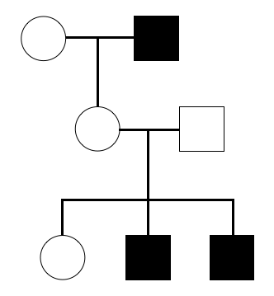

6. The pattern of inheritance shown in the pedigree above is most likely

(a) autosomal dominant.
(b) autosomal recessive.
(c) X-linked dominant.
(d) X-linked recessive.

7. Which of the following techniques does not involve the use of manipulated DNA?

(a) Microarray
(b) Polymerase chain reaction
(c) Artificial selection
(d) Profiling

8. During transcription, RNA polymerase transcribes a new mRNA molecule from the DNA:

(a) coding strand.
(b) template strand.
(c) sense strand.
(d) degenerate strand.

9. How many different gametes can be produced through the process of independent assortment for the genotype EeFfGgHH, assuming that each gene is found on a different chromosome?

(a) 8
(b) 16
(c) 4
(d) 64

The information below relates to question 10.

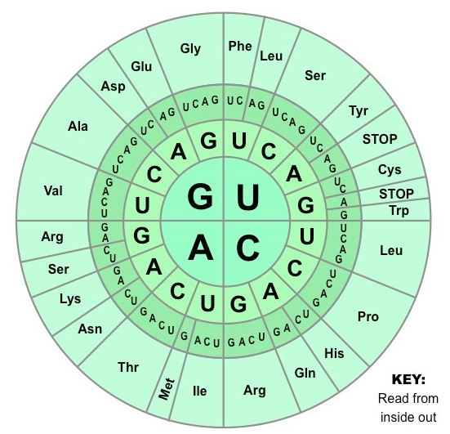

10. The diagram above shows all the codons in mRNA that code for different amino acids. Which of the following shows the correct codon and amino acid pairing?

(a) UAA = asparagine
(b) UCA = isoleucine
(c) CUC = leucine
(d) GGC = arginine

11. Non-disjunction may occur during meiotic division. Non-disjunction is caused by

(a) homologous chromosomes failing to separate properly.
(b) genetic information being exchanged between homologues.
(c) exposure to a chemical mutagen.
(d) abnormal spindle fibre formation.

12. A transgenic organism

(a) contains plasmids from the bacteria Agrobacterium tumefaciens.
(b) is infertile due to genetic manipulation.
(c) is resistant to antibiotics.
(d) can express a gene not normally present in its genome.

The image below relates to question 13.

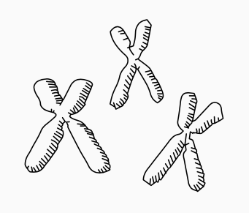

13. During which cellular process would you find DNA condensed into the characteristic 'X' shape, as shown in the image above?

(a) Transcription
(b) Translation
(c) Mitosis
(d) Cytokinesis

The table below relates to question 14.

Species | Hybrid DNA denaturation temperature (ºC)
T | 72
U | 78
V | 55
W | 49

14. Molecular hybridisation involves the heating of DNA molecules to break the hydrogen bonds between the two strands. An investigation was conducted which compared the DNA of a known species, S, to that of four different organisms, T, U, V and W. Single- stranded DNA from species S was hybridised with homologous DNA from each of the four species. The samples were reheated and the temperature at which the hybridised molecules denatured was recorded. Based on these temperatures, which species is most closely related to species S?

(a) T
(b) U
(c) V
(d) W

15. Germ line mutations lead to evolutionary change within a species as a result of

(a) changes in the appearance of an organism.
(b) the introduction of new alleles into the gene pool.
(c) increasing incompatibility of gametes.
(d) differences in the function and/or structure of proteins between individuals.

The diagram below refers to questions 16 and 17.

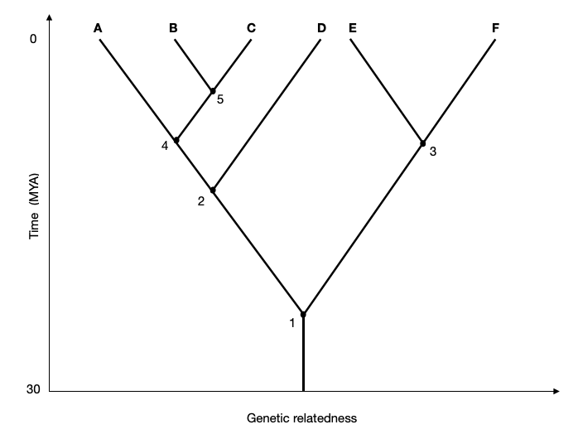

16. An evolutionary biologist was investigating the genetic relatedness for species of black cockatoos throughout Australia. A phylogenetic tree for black cockatoo relatedness is shown above. A common ancestor for species A and D is most likely at point

(a) 1
(b) 2
(c) 3
(d) 4

17. Which of the following two species shown on the diagram are most distantly related?

(a) A and C
(b) C and B
(c) E and F
(d) B and F

18. Restriction enzymes 'cut' DNA at specific areas called

(a) cleavage sites.
(b) recognition sites.
(c) recombinant sites.
(d) attraction sites.

19. A test cross was performed between two adult mice to determine their genotype for a particular trait. If the allelic frequency of the resulting offspring was 25% homozygous dominant, 50% heterozygous and 25% homozygous recessive for the trait, the parent mice must be

(a) both homozygous dominant.
(b) homozygous dominant and homozygous recessive.
(c) heterozygous and homozygous recessive.
(d) both heterozygous.

20. Which of the following statements regarding comparative embryology is true?
Comparative embryology

(a) reveals similarities in the embryonic development of mammals.
(b) compares the pattern of embryonic development between vertebrate groups.
(c) reveals embryonic structures common to all vertebrates.
(d) identifies the different stages of embryonic development in mammals.

21. Skin pigmentation in humans is determined by a number of different genes across the genome. This type of inheritance is termed

(a) multiple allelic.
(b) polymorphic.
(c) polygenic.
(d) transgenic.

22. Which of the following statements is true of analogous structures? They

(a) are present in all vertebrates in the embryonic stage.
(b) are similar in structure but possess a different function.
(c) show a shared evolutionary origin of different taxonomic groups.
(d) are different in structure while sharing a similar function.

23. Index fossils

(a) contain radioactive isotopes that enable scientists to determine their exact age.
(b) are used to determine the relative age of rock strata and fossils they contain.
(c) are the remains of species that persisted over a long geological timeframe.
(d) provide evidence for evolution as they exhibit morphologies common to both ancestral and descendent species.

24. The evolution of DDT resistance in mosquitoes is a result of natural selection. Resistance to this pesticide most likely emerged because

(a) alternate alleles were present in the gene pool.
(b) the population size of mosquitoes was very large.
(c) mosquitoes reproduce sexually.
(d) only female mosquitoes were affected.

25. The genetic code is described as being redundant. This means that

(a) some genes code for more than one trait.
(b) every organism has more DNA than can be expressed.
(c) some amino acids are coded for by more than one codon.
(d) some codons code for more than one amino acid.

26. The separation and subsequent geographical isolation of a species gene pool is an essential component for

(a) genetic drift.
(b) allopatric speciation.
(c) the founder effect.
(d) natural selection.

27. Gene expression refers to

(a) the synthesis of mRNA from functional genes.
(b) the synthesis of a functioning protein using the DNA code.
(c) the control of mRNA synthesis in the nucleus.
(d) the modification of mRNA following transcription.

28. Which of the following statements does not describe a similarity between sexual selection and natural selection?

(a) Selection always involves direct competition between individuals of the same species.
(b) For both types of selection to occur, there must be genetic variation within a population.
(c) Individuals with favourable genetic traits or variations produce more offspring than other individuals.
(d) Variation must be heritable.

29. Which of the following is true of macroevolution?

(a) The rate of evolutionary change is constant.
(b) Changes occur over long periods of geological time.
(c) Macroevolution only occurs in response to geological isolation.
(d) The introduction of new alleles into a population drives macroevolution.

The image below relates to question 30.

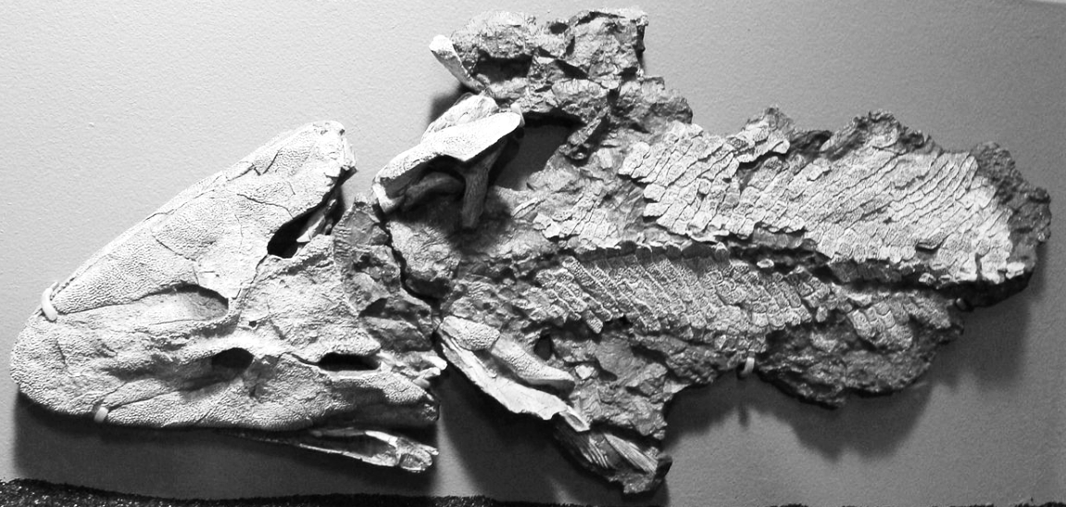

30. The Tiktaalik, shown above, is a 375-million-year-old fossil that was unearthed in the Canadian arctic. It has been described as having the head of a crocodile and gills of a fish. Additionally, Tiktaalik had scales and fins like most fish, and sturdy bones in its wrists, neck and shoulders like four-legged vertebrates. As such, Tiktaalik is considered a transitional form by palaeontologists. Which statement best describes how a transitional form provides evidence for the theory of evolution?

(a) Transitional forms possess characteristics that are a blend of those from both common ancestors and direct descendants.
(b) Transitional fossils have been uncovered in places where their descendants are known to exist.
(c) Transitional forms possess a combination of features that show an evolutionary transition between their ancestors and descendants.
(d) The characteristics of transitional forms provide a phylogenetic link between vertebrate groups.

End of Section One

Section Two: Short answer 50% (100 Marks)

This section has five questions. Answer all questions. Write your answers in the spaces provided.

Supplementary pages for planning/continuing your answers to questions are provided at the end of this Question/Answer booklet. If you use these pages to continue an answer, indicate at the original answer where the answer is continued, i.e. give the page number.

Suggested working time: 90 minutes.

Question 31 (20 marks)

(a) Define the following terms.

(i) Genotype (1 mark)

(ii) Phenotype (1 mark)

(iii) Genome (1 mark)

(b) Explain the difference between a gene and an allele. (2 marks)

(c) Identify the factors that determine an organism's phenotype. (2 marks)

In snow peas, the pod shape can be either flat or curled, with flat pods showing dominance over curled pods. A market gardener wanted to ensure all future snow pea crops only produced flat pods.

(d) Explain how the market gardener could determine whether a snow pea plant is homozygous or heterozygous for flat pods. Use the Punnett squares below to help support your answer. (8 marks)

While harvesting the snow peas, the market gardener noticed several plants had produced pods that were twice as big as the 'normal' pea pods. His neighbour suggested it was the result of a mutation that is not uncommon in plants.

(e) Identify and describe the type of mutation that could cause this phenomenon. (3 marks)

(f) Explain one (1) issue associated with growing crops with a high level of homozygosity. (2 marks)

Question 32 (20 marks)

Ultraviolet (UV) radiation is a form of short wavelength radiation (4 - 400nm) with mutagenic properties. When cells are exposed to UV radiation, the DNA absorbs the energy and normal base-pair structures can be disrupted. UV radiation causes the formation of pyrimidine dimers - adjacent thymine or cytosine molecules become linked by covalent bonds (see image below).

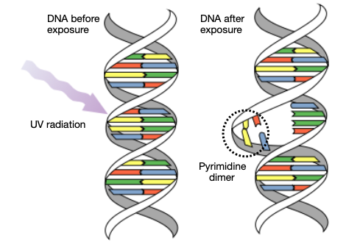

While both prokaryotic and eukaryotic cells have evolved different mechanisms to repair UV damage, excessive exposure can result in severe mutations, cancer and cell death. Most bacteria are killed by the effects of UV radiation, so it is often used to sterilise clinical equipment and surfaces.

(a) Describe how the formation of pyrimidine dimers could affect normal cellular processes.
(3 marks)

A group of biology students were investigating the effect of UV exposure on two different bacteria that cause illness in humans - Escherichia coli and Staphylococcus aureus. The aim of their investigation was to determine how long each type of bacteria had to be exposed to UV radiation to cause sufficient cell death.

Both bacteria species were cultured in nutrient broth for 24 hours at 37ºC. For each time trial, 10 nutrient agar Petri dishes were inoculated with 1.0mL of the bacteria broth. Petri dishes were placed in a UV illuminator box set at a wavelength of 260nm (maximum absorption of UV by DNA) for the appropriate time.

Following exposure to UV radiation, the Petri dishes were incubated for 24 hours at 37ºC. Bacterial growth was determined by estimating the percentage coverage of bacteria on each Petri dish. The results from this investigation are shown in Table 1.

Table 1 - Bacterial growth after exposure to UV radiation.

UV exposure time (mins) | Mean bacterial growth as  % coverage
 | Escherichia coli | Staphylococcus aureus
0 | 80 | 85
1 | 35 | 60
2 | 5 | 45
5 | 2 | 15
10 | 1 | 8
15 | 0 | 6
20 | 0 | 4
25 | 0 | 1
30 | 0 | 0

(b) Construct a line graph of the data in Table 1 on the grid below. (6 marks)
(A spare grid is available on page 38)



(c) Explain why the bacteria broth and inoculated Petri dishes were incubated at 37ºC.
(2 marks)

(d) Suggest two (2) reasons for inoculating 10 Petri dishes with the bacteria broth for each UV exposure time. (2 marks)

(d) Use your graph to estimate the UV exposure time required to completely inhibit growth of;

(i) Escherichia coli (1 mark)

(ii) Staphylococcus aureus (1 mark)

(e) Does this investigation have an appropriate control? Explain your response. (3 marks)

(f) State two (2) ways in which the students could improve the reliability of the investigation. (2 marks)

Question 33 (20 marks)

(a) Compare the process of mitosis and meiosis by completing the table below. (6 marks)

Mitosis | Meiosis

Bacteria do not reproduce sexually and yet they are the most diverse group of organisms on Earth.

(b) Name the process by which bacteria reproduce. (1 mark)

(c) Explain two (2) ways the genetic diversity of a bacterial species can be increased.
(4 marks)

1. 2.
Agrobacterium tumefaciens is a species of soil-borne bacteria that can infect plant cells and cause crown gall disease. A. tumefaciens is widely used in recombinant DNA technology as a vector for gene transfer.

(d) Construct a labelled flow diagram outlining the stages involved in the development of a transgenic plant using Agrobacterium tumefaciens. (6 marks)

(e) Describe how scientists identify which bacterial cells contain recombined DNA. (3 marks)

Question 34 (20 marks)

There are six subspecies of carpet python (Morelia spilota) in Australia. The table below contains information relating to two subspecies of the carpet python.

 | 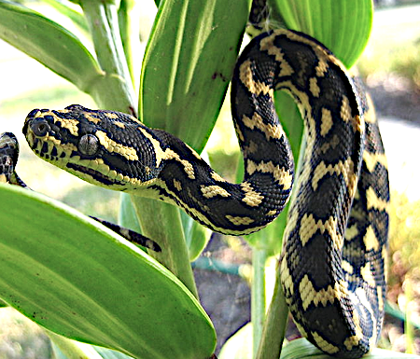  Jungle carpet python | 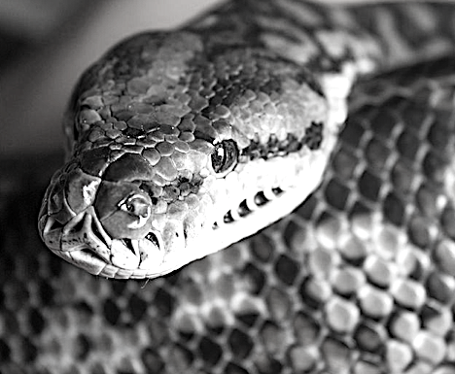  Murray Darling carpet python
Colouration | Black with bright yellow diamond banding. | Black and grey mottled skin with cream underside.
Habitat | Tropical rainforest | Inland open eucalypt forest and rocky outcrops.

(a) Explain how natural selection allowed for the evolution of these subspecies. (5 marks)

A scientist used mitochondrial DNA (mtDNA) to determine subspecies divergence times.

(b) Suggest three (3) reasons why mtDNA was used in this investigation. (3 marks)

1. 2. 3.
(c) Describe how each of the following provide evidence for evolution.

(i) Homologous structures (3 marks)

(ii) Vestigial organs/structures (3 marks)

(iii) Biogeography (3 marks)

(d) Use a specific example to explain how sexual selection may increase the frequency of a trait that does not improve an organism's chance of survival and reproductive success. (3 marks)

Question 35 (20 marks)

A large wildlife sanctuary was monitoring the breeding behaviour of a population of the carnivorous agile antechinus (Antechinus agilis), shown below.

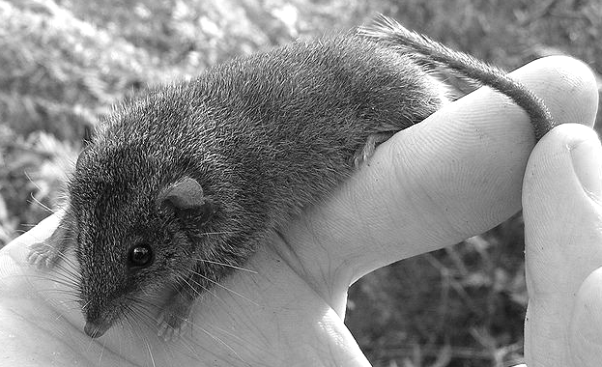

Like most species from the family Dasyuridae, the agile antechinus is highly promiscuous. Each female is able to produce a litter of up to 12 offspring by multiple fathers.

Researchers profiled the DNA of four juvenile agile antechinus from one litter, against the DNA from the three possible fathers. The purpose of this research was to select juveniles with different fathers for a breeding program at the Melbourne Zoo.

A selection of comparable short tandem repeats (STRs) was isolated from the genome of each antechinus.

(a) Define 'short tandem repeat'. (2 marks)

(b) Explain why STRs are used in genetic profiling. (3 marks)

Gel electrophoresis was used to visualise and compare the antechinus DNA.

(c) Outline the basic principles behind the use of gel electrophoresis for DNA profiling.
(5 marks)

The resulting DNA 'fingerprint' of each possible father and juvenile antechinus is shown below.

Juveniles
Possible Fathers
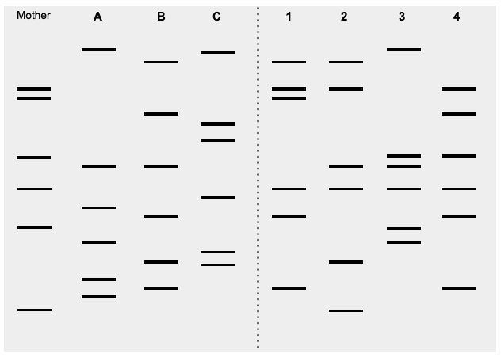

(d) Using the information above, identify the father of each juvenile antechinus. (4 marks)

Juvenile 1 Juvenile 3

Juvenile 2 Juvenile 4
(e) Based on the paternity results, which of the offspring would be most suitable for the breeding program? Explain your choice. (2 marks)

Captive bred animals are eventually released into their natural habitat.

(f) Discuss one (1) factor that should be considered prior to their release. (2 marks)

(g) Identify two (2) other applications of gel electrophoresis in biotechnology. (2 marks)

End of Section Two

Section Three: Extended answer 20% (40 marks)

Section Three consists of four questions.

Questions 36 and 37 form Part A. Questions 38 and 39 form Part B. Answer one question from Part A and one question from Part B.

Use black or blue pen for this section. Do not use erasable or gel pens. Only graphs and diagrams may be drawn in pencil. Responses can include; labelled diagrams with explanatory notes; lists of points with linking sentences; labelled tables and/or graphs; and/or annotated flow diagrams with introductory notes.

Supplementary pages for planning/continuing your answers to questions are provided at the end of this Question/Answer booklet. If you use these pages to continue an answer, indicate at the original answer where the answer is continued, i.e. give the page number.

Suggested working time: 50 minutes

Part A

Choose either Question 36 or Question 37.

Indicate the question you will answer by ticking the box next to the question. Write your answer on pages 26 - 29. When you have answered your first question, turn to page 30 and indicate on that page the second question you will answer.

Question 36 (20 marks)

(a) Describe the process of DNA replication and its importance to the survival of all living organisms.
(10 marks)

(b) Discuss positives and negatives of producing genetically modified agricultural crops.
(10 marks)

Question 37 (20 marks)

(a) Describe the process of translation in a cell.
(10 marks)
(b) Discuss how biotechnology can help to reduce the risk of extinction for endangered species.
(10 marks)

Question number:

Question number:

Question number:

Question number:

Part B

Choose either Question 38 or Question 39.

Indicate the question you will answer by ticking the box next to the question. Write your answer on the pages provided.

Question 38 (20 marks)

(a) Describe how gene flow and mutation influence genetic variation in populations.
(10 marks)
(b) Discuss the concept of genetic drift and associated effects on genetic diversity.
(10 marks)

Question 39 (20 marks)

(a) Describe the process of selective breeding in agricultural livestock. Identify any problems that may arise as a result of this process.
(10 marks)

(b) Discuss the concept of adaptive radiation as a mechanism for speciation. Use examples to support your response.
(10 marks)

End of questions

Question number:

Question number:
Question number:

Question number:

Supplementary page
Question number:

Supplementary page
Question number:

Spare grid



ACKNOWLEDGEMENTS

Question 6
Pedigree diagram
Author constructed

Question 10
Amino acid codon chart
https://ib.bioninja.com.au/standard-level/topic-2-molecular-biology/27-dna-replication-transcri/genetic-code.html

Question 13
Chromosome diagram
Creative Commons Attribution 2.0 Generic license.
Graphodatsky, Alexander S; Trifonov, Vladimir A; Stanyon, Roscoe (2011). "The genome diversity and karyotype evolution of mammals". Molecular Cytogenetics 4 (22).

Question 16 and 17
Phylogenetic chart
Author constructed

Question 30
Tiktaalik fossil image
Creative Commons Attribution-Share Alike 2.0 Generic license.
Matt Mechtley from Tempe, Arizona, USA

Question 32
DNA UV mutation diagram
Wikimedia Commons Public Domain
NASA/David Herring

Question 34
Jungle Carpet Python image
Wikimedia Commons
Creative Commons Attribution-Share Alike 4.0 International, 3.0 Unported, 2.5 Generic, 2.0 Generic and 1.0 Generic license.
Kyle A. Zimmerman

Murray Darling Carpet Python image
Wikimedia Commons
Creative Commons Attribution-Share Alike 3.0 Unported license.
Scarlet23

Question 35
Antechinus agilis image
Wikimedia Commons
Creative Commons Attribution 2.0 Generic license.
Michael Sale

DNA gel diagram
Author constructed

